

Module Name: Database Systems

Module Code: 15CSIS03C

Project Assignment: phase (3) Relational Database Schema

Module Leader: Dr. Doa’a El-Zanfaly



**A management database system for Macdonald’s Fast Food Company**

**Team members**

|  |  |  |  |
| --- | --- | --- | --- |
| Name | ID | Group | E-mail |
| Ahmed Mahmoud Shedid | 135824 | A1 | Ahmed135824@bue.edu.eg |
| Ameer Ayman Abdelhamid | 135058 | A2 | Ameer135058@bue.edu.eg |
| Anas Mohammed Hassan | 138778 | A2 | Anas138778@bue.edu.eg |
|  | | | |



Updated ERD Improved by the TA’s Notes and Feedback

 **The changes that have been made on the ERD:**

* McDonald’s Cairo entity has been changed to **McDonald’s Community** to cover all the general information concerning MacDonald’s restaurant in Cairo.
* The Training attribute in McCarrer entity has been changed from a multi-value to a single value.
* The relationship in the Employee attribute has been fixed to an **obligatory relationship** whereas there must be one manager supervises many employees and many employees must be supervised by at least one manager.
* **The loop** between the Employee, Delivery and Menu attributes has been removed by deleting the relationship between the delivery and the food menu.
* The **Delivery entity’s primary key**, which was the hot line 19991, has been deleted and replaced by the delivery order number attribute.
* An attribute **“Pilot Name”** has been added to the delivery entity to record the name of the delivery man.
* **The subclasses** in the Menu attribute have been re-arranged and represented in two new subclasses **“Main Meals”** and **“Season’s Special Meals”** to cover all the sides in the menu’s context and the food list.

Devided ERD on the Team Members’ Tasks

* **Ahmed Mahmoud’s** part of entities and relationships:

Macdonald’s Community, McCareer, McService

* **Ameer Ayman’s** part entities and relationships:

Employee, Delivery, Menu

The Relational Database Schema

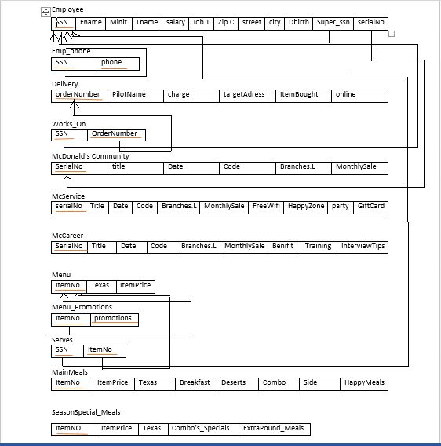

Data Dectionary

**Employee:**

|  |  |  |  |
| --- | --- | --- | --- |
| Attribute | Data Type | Size | Constraints |
| Ssn Number | Int | - | PK |
| First Name | Varchar | (15) |  |
| Middle Name | char | - |  |
| Last Name | Varchar | (20) |  |
| Date of Birth | Date | - |  |
| Job Title | Varchar | (30) |  |
| Address/City | Varchar | (10) |  |
| Address/ Street | Varchar | (20) |  |
| Address/Zip Code | Int | - |  |
| Salary | Int | - |  |

**Emp_phone:**

|  |  |  |  |
| --- | --- | --- | --- |
| Attribute | Data Type | Size | Constraints |
| Ssn Number | Int | - | PK |
| Phone | Int | - | PK |

**Delivery:**

|  |  |  |  |
| --- | --- | --- | --- |
| Attribute | Data Type | Size | Constraints |
| Order Number | Int | - | PK |
| Pilot Name | Varchar | (15) |  |
| Delivery Charge | Int | - |  |
| Target Address | Varchar | (30) |  |
| Item Bought | Varchar | (30) |  |
| Order Online | Varchar | (30) |  |

**Works_on:**

|  |  |  |  |
| --- | --- | --- | --- |
| Attribute | Data Type | Size | Constraints |
| Ssn Number | Int | - | PK |
| Order Number | Int | - | PK |

**McDonald’s Community:**

|  |  |  |  |
| --- | --- | --- | --- |
| Attribute | Data Type | Size | Constraints |
| Serial Number | Int | - | PK |
| L.News/ Title | Varchar | (20) |  |
| L.News/ Date | Date | - |  |
| L.News/ Code | Int | - |  |
| Branches’ Locations | Varchar | (30) |  |
| Monthly Sale | Int | - |  |

**McDonald’s Services:**

|  |  |  |  |
| --- | --- | --- | --- |
| Attribute | Data Type | Size | Constraints |
| Serial Number | Int | - | PK |
| Happy Zone | Varchar | (30) |  |
| Birthday Party | Varchar | (30) |  |
| Gift Card | char | - |  |
| Free Wifi | char | - |  |

**McDonald’s Career:**

|  |  |  |  |
| --- | --- | --- | --- |
| Attribute | Data Type | Size | Constraints |
| Serial Number | Int | - | PK |
| Benefit | Varchar | (20) |  |
| Working | Varchar | (20) |  |
| Training | Varchar | (20) |  |

**Menu:**

|  |  |  |  |
| --- | --- | --- | --- |
| Attribute | Data Type | Size | Constraints |
| Item Number | Int | - | PK |
| Item Price | Int | - |  |
| Taxes | Int | - |  |

**Menu_Promotions:**

|  |  |  |  |
| --- | --- | --- | --- |
| Attribute | Data Type | Size | Constraints |
| Item Number | Int | - | PK |
| Promotions | Varchar | (30) |  |

**Main Meals:**

|  |  |  |  |
| --- | --- | --- | --- |
| Attribute | Data Type | Size | Constraints |
| Item Number | Int | - | PK |
| Breakfast | Varchar | (30) |  |
| Combo | Varchar | (30) |  |
| Desert | Varchar | (30) |  |
| Sides | Varchar | (30) |  |
| Happy Meals | Varchar | (30) |  |

Season’s Special Meals:

|  |  |  |  |
| --- | --- | --- | --- |
| Attribute | Data Type | Size | Constraints |
| Item Number | Int | - | PK |
| Combo’s Special | Varchar | (30) |  |
| Extra Pounds Meals | Varchar | (30) |  |

